ASSOCIATION OF THE TCF7L2 RS12255372 POLYMORPHISM WITH C-PEPTIDE LEVELS, INSULIN RESISTANCE, AND SUSCEPTIBILITY TO TYPE 2 DIABETES MELLITUS IN AN INDONESIAN POPULATION
Prince Saputra 1, Miswar Fattah 2, Himawan Sanusi 3,7, Andi Alfian Zainuddin ⁴, Rusdina Bte Latju ⁵,
Mansyur Arif 6, Liong Boy Kurniawan 6*

1 Doctoral Program, Faculty of Medicine, Hasanuddin University, Makassar, Indonesia
² Research and Specialty Test Development Division, PT Prodia Widyahusada Tbk, Jakarta, Indonesia
³ Department of Internal Medicine, Faculty of Medicine, Hasanuddin University, Makassar, Indonesia
⁴ Department of Community Medicine, Faculty of Medicine, Hasanuddin University, Makassar, Indonesia
⁵ Department of Pharmacology, Faculty of Medicine, Hasanuddin University, Makassar, Indonesia
⁶ Department of Clinical Pathology, Faculty of Medicine, Hasanuddin University, Makassar, Indonesia
⁷ Dr. Wahidin Sudirohusodo National General Hospital, Makassar, Indonesia
*Corresponding author: liongboykurniawan@yahoo.com

ABSTRACT

Introduction: Type 2 diabetes mellitus (T2DM) is a multifactorial metabolic disorder caused by the interaction of insulin resistance, pancreatic β-cell dysfunction, and genetic susceptibility. Although the Transcription Factor 7-Like 2 (TCF7L2) gene is a major susceptibility locus for T2DM, the distribution and metabolic significance of the rs12255372 polymorphism remain poorly characterized in Indonesians. Materials and Methods: This case–control study included 181 participants comprising 111 patients with T2DM, 60 non-diabetic controls, and 10 individuals with type 1 diabetes mellitus as a descriptive comparison group. Genotyping was performed using polymerase chain reaction with Sanger sequencing validation. Fasting glucose, HbA1c, insulin, and C-peptide were measured using standardized methods, and insulin resistance was assessed using the Homeostasis Model Assessment of Insulin Resistance (HOMA-IR). Statistical analyses included Fisher's exact test, Mann–Whitney U test, and multivariate logistic regression. Results: The GG genotype predominated in both groups, whereas the GT genotype occurred in 3.6% of patients with T2DM and 3.3% of controls; no TT genotype was identified. The rs12255372 polymorphism was not associated with T2DM susceptibility (OR 1.08, 95% CI 0.19–6.16; P=0.93). C-peptide and HOMA-IR did not differ significantly between genotypes. Age, body mass index, and sex were independent predictors of T2DM. Conclusions: The TCF7L2 rs12255372 polymorphism was not associated with T2DM susceptibility, C-peptide levels, or insulin resistance in this Indonesian population. The low frequency of the T allele suggests limited contribution to T2DM susceptibility and highlights ethnic differences in T2DM genetic architecture.

Keywords

TCF7L2, rs12255372, type 2 diabetes mellitus, C-peptide, insulin resistance, HOMA-IR, Indonesian population.

INTRODUCTION

Type 2 diabetes mellitus (T2DM) is a chronic metabolic disorder characterized by persistent hyperglycemia resulting from impaired insulin secretion, insulin resistance, or both mechanisms, and is associated with multiple metabolic complications affecting the cardiovascular, renal, and other organ systems [1,2]. T2DM is among the leading non-communicable diseases worldwide and represents a major contributor to premature mortality, disability, and healthcare expenditure. According to the 11th International Diabetes Federation (IDF) Diabetes Atlas, approximately 589 million adults were living with diabetes in 2024, with the greatest increases occurring in low- and middle-income countries, including Indonesia [3]. The prevalence of T2DM has increased substantially in Southeast Asia, where rapid urbanization, dietary transition, reduced physical activity, obesity, and population aging contribute to the growing burden of disease [2,4]. Indonesia is among the countries with the highest diabetes burden in the Western Pacific region, underscoring the need for population-specific prevention strategies and improved genetic risk stratification [3]. However, most genetic evidence regarding TCF7L2 originates from European populations, whereas data from Southeast Asian populations remain scarce.
The pathogenesis of T2DM is multifactorial and involves a complex interaction between environmental exposures, metabolic dysregulation, and genetic susceptibility. Genome-wide association studies (GWAS) have identified multiple loci associated with T2DM risk, insulin secretion, and glucose homeostasis. Among these, Transcription Factor 7-Like 2 (TCF7L2) has emerged as one of the most consistently replicated susceptibility genes across diverse ethnic populations. Located on chromosome 10q25.2–q25.3, TCF7L2 encodes a transcription factor involved in the Wnt/β-catenin signaling pathway, which regulates pancreatic β-cell proliferation, incretin signaling, insulin secretion, and glucose metabolism [5,6,7,8].
Among the TCF7L2 variants associated with T2DM, rs12255372 is one of the most extensively investigated. This intronic single nucleotide polymorphism (SNP), characterized by a G-to-T substitution, has been associated with increased T2DM risk, impaired insulin secretion, and altered β-cell function in several populations. However, the magnitude and direction of this association vary substantially across ethnic groups. Studies in European, North African, Middle Eastern, and South Asian populations have reported higher frequencies of the T allele and stronger associations with T2DM risk than those observed in many Asian populations, suggesting important ancestry-related differences in allele distribution, linkage disequilibrium structure, and diabetogenic effect size [7,9,10,11,12,13]. Recent systematic reviews also support the contribution of TCF7L2 polymorphisms to diabetes susceptibility while emphasizing marked ethnic heterogeneity in effect size and allele distribution [14,15].
Despite the growing body of evidence on TCF7L2 polymorphisms, data regarding rs12255372 in Indonesian populations remain very limited. Moreover, most available studies focus primarily on diabetes susceptibility and do not simultaneously integrate genotyping with biomarkers reflecting β-cell function and insulin resistance. This gap is particularly relevant because TCF7L2-related diabetogenic mechanisms are believed to act predominantly through impaired β-cell function rather than peripheral insulin resistance. Experimental evidence indicates that TCF7L2 primarily affects β-cell function through Wnt/β-catenin signaling and incretin-mediated insulin secretion rather than peripheral insulin sensitivity [8,16,17,18]. Consequently, evaluating rs12255372 in relation not only to T2DM susceptibility but also to C-peptide and HOMA-IR may provide a more integrated understanding of its potential metabolic relevance.

The present study was designed to address this gap by evaluating the association of TCF7L2 rs12255372 polymorphism with T2DM susceptibility, C-peptide levels, and insulin resistance in an Indonesian population using PCR-based genotyping validated by Sanger sequencing. In addition to comparing T2DM and non-diabetic participants, this study also included a small T1DM group as a descriptive metabolic comparison arm to illustrate the spectrum of β-cell dysfunction. By integrating sequencing-validated genotyping with biochemical assessment of glucose metabolism, this study provides population-specific evidence regarding the contribution of rs12255372 to T2DM pathophysiology in Indonesia and may contribute to future precision medicine, genetic risk prediction, and polygenic risk stratification strategies in Southeast Asian populations [19,20,21].

MATERIALS AND METHODS

Study Design and Participants

This observational analytic study employed a case–control design and was conducted between July and December 2025. A total of 181 participants were enrolled, consisting of 111 patients with T2DM, 60 non-diabetic controls, and 10 individuals with T1DM included as a descriptive metabolic comparison group.
T2DM diagnosis was established according to the American Diabetes Association Standards of Care 2025 [22]. Non-diabetic controls had normal fasting blood glucose levels and no previous history of diabetes mellitus. T1DM participants were not included in the primary case–control association analysis but were incorporated as a descriptive comparison group to illustrate the spectrum of β-cell dysfunction across diabetes phenotypes. Eligible participants were aged ≥18 years and provided written informed consent. Individuals with severe systemic illness, pregnancy, malignancy, acute infection, or incomplete laboratory data were excluded. The study protocol was approved by the Health Research Ethics Committee of Hasanuddin University, Indonesia (Approval No. 563/UN4.6.4.5.31/PP36/2025), and written informed consent was obtained from all participants prior to enrollment.

DNA Extraction and Genotyping
Peripheral venous blood samples (3–5 mL) were collected in EDTA tubes from all participants. Genomic DNA was extracted from 200 μL of whole blood using the Geneaid Genomic DNA Mini Kit (Blood, Geneaid Biotech Ltd., Taiwan) according to the manufacturer's instructions. Briefly, whole blood samples were subjected to proteinase K digestion, cell lysis, DNA binding onto a silica membrane, washing, and elution with 100 μL of elution buffer. Purified DNA was stored at −40°C until PCR amplification.
The TCF7L2 rs12255372 polymorphism was amplified by polymerase chain reaction (PCR). The primer sequences were Forward 5′-CTGGAAACTAAGGCGTGAGG-3′ and Reverse 5′-GGGTCGATGTTGTTGAGCTT-3′, generating a 346-bp amplicon. PCR amplification consisted of an initial denaturation at 95°C for 5 min, followed by 40 cycles of denaturation at 95°C for 15 s, annealing at 65°C for 15 s, and extension at 72°C for 45 s, with a final extension at 72°C for 15 min.

Table 1. Primer sequences used for amplification of TCF7L2 rs12255372
Primer | Sequence (5'→3') | Product size
Forward  Reverse | CTGGAAACTAAGGCGTGAGG  GGGTCGATGTTGTTGAGCTT | 346 bp  346 bp

PCR products were subsequently validated by Sanger sequencing. Sequence chromatograms were analyzed using Geneious software and compared with the NCBI dbSNP reference sequence (Assay ID C_291484_20). Genotypes were assigned based on nucleotide peaks at the polymorphic locus, with a single guanine peak indicating the GG genotype and overlapping guanine/thymine peaks indicating the GT genotype. Representative chromatograms were used to verify the accuracy of PCR-based genotyping and minimize allele misclassification.

Biochemical Analysis
Fasting blood glucose, HbA1c, insulin, and C-peptide levels were measured using standardized laboratory procedures. Insulin resistance was assessed using the Homeostasis Model Assessment of Insulin Resistance (HOMA-IR), calculated as follows:
HOMA-IR = fasting insulin × fasting glucose / 405
C-peptide was included as a marker of endogenous insulin secretion and β-cell function. This study was reported in accordance with the Strengthening the Reporting of Genetic Association Studies (STREGA) guidelines.

Statistical Analysis
Continuous variables were expressed as mean ± standard deviation or median (interquartile range) depending on data distribution. Data distribution was assessed prior to analysis; normally distributed variables are presented as mean ± standard deviation, whereas non-normally distributed variables are presented as median (interquartile range). Comparisons between groups were performed using the Mann–Whitney U test. Genotype and allele distributions were analyzed using Fisher’s exact test. Hardy–Weinberg equilibrium (HWE) was evaluated in the control group to assess population genetic stability and genotyping reliability.
To identify independent predictors of T2DM susceptibility, multivariate logistic regression analysis was performed. Odds ratios (ORs) with 95% confidence intervals (CIs) were calculated. Statistical significance was defined as p<0.05. All analyses were performed using IBM SPSS Statistics version 26.0 (IBM Corp., Armonk, NY, USA).
Given the extremely low frequency of the rs12255372 T allele and the absence of TT homozygous individuals, post-hoc statistical power was considered limited for detecting small genetic effects. Nevertheless, the observed allele distribution itself was regarded as informative for characterizing population-specific genetic heterogeneity in the Indonesian setting.

RESULTS

Characteristics of Study Participants
The clinical and biochemical characteristics of the study participants are presented in Table 1. Compared with the non-diabetic control group, participants with T2DM were significantly older and exhibited significantly higher fasting blood glucose, HbA1c, insulin, and HOMA-IR values. Median C-peptide levels were relatively preserved in the T2DM group but were markedly reduced in the T1DM group, reflecting severe β-cell dysfunction in autoimmune diabetes.

Table 2. Characteristics of Study Participants
Variable | T2DM (n=111) | Non-DM (n=60) | T1DM (n=10) | p-value
Age (years) | 40.3 ± 6.73 | 31.5 ± 7.18 | 24.8 ± 6.05 | <0.001
Sex (M/F) | 23/88 | 4/56 | 2/8 | 0.001
BMI (kg/m²) | 23.2 ± 1.40 | 23.6 ± 1.69 | 22.7 ± 1.83 | 0.008
Fasting glucose (mg/dL) | 159 (142–193) | 87 (82–91) | 199 (190–210) | <0.001
HbA1c (%) | 8.83 ± 1.68 | 5.1 ± 0.17 | 8.4 ± 1.14 | <0.001
Insulin | 9.8 ± 10.40 | 7.36 ± 1.38 | 2.0 ± 0.27 | <0.001
C-peptide (ng/mL) | 2.18 (1.59–2.53) | 2.33 (1.67–2.55) | 0.30 (0.20–0.30) | <0.001
HOMA-IR | 3.5 (2.8–3.9) | 1.5 (1.3–1.7) | 1.0 (0.9–1.1) | <0.001

The age distribution of study participants across diagnostic groups is shown in Figure 1. More than half of participants with T2DM were in the 41–50-year age category, whereas non-diabetic controls were predominantly distributed across the younger age groups (≤30 and 31–40 years). All T1DM participants were within the ≤30-year age category, consistent with the younger age profile typically observed in autoimmune diabetes.

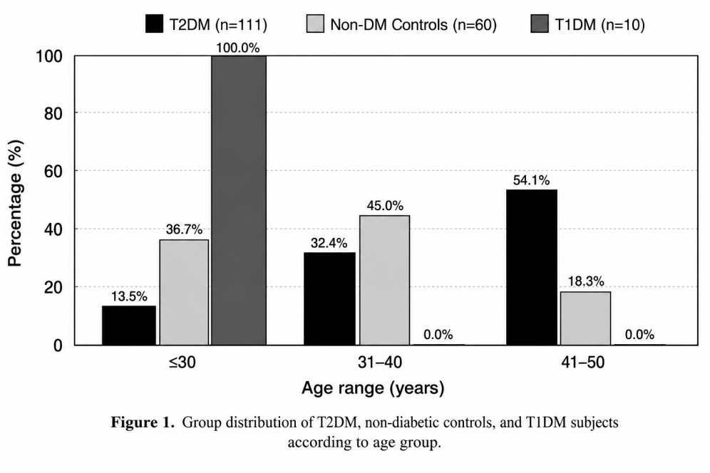
Figure 1. Age-group distribution of participants with T2DM, non-diabetic controls, and T1DM.

Genotype Distribution and Hardy–Weinberg Equilibrium
The distribution of rs12255372 genotypes and alleles is presented in Table 2. The GG genotype predominated in both the T2DM and control groups, accounting for more than 96% of participants in each group. The GT genotype was observed in only a small proportion of participants, whereas no TT genotype was detected. The genotype distribution in the control group did not deviate from Hardy–Weinberg equilibrium (p = 1.000), supporting genotyping validity and population stability.

Table 3. Distribution of rs12255372 Genotypes and Alleles
Genotype/Allele | T2DM (n=111) | Non-DM (n=60) | p-value
GG  GT | 107 (96.4%)  4 (3.6%) | 58 (96.7%)  2 (3.3%) | 0.93
G allele | 218 (98.2%) | 118 (98.3%) | 0.92
T allele | 4 (1.8%) | 2 (1.7%)

Sequencing Chromatogram Validation

Representative Sanger sequencing chromatograms demonstrated clear differentiation between wild-type GG and heterozygous GT genotypes.
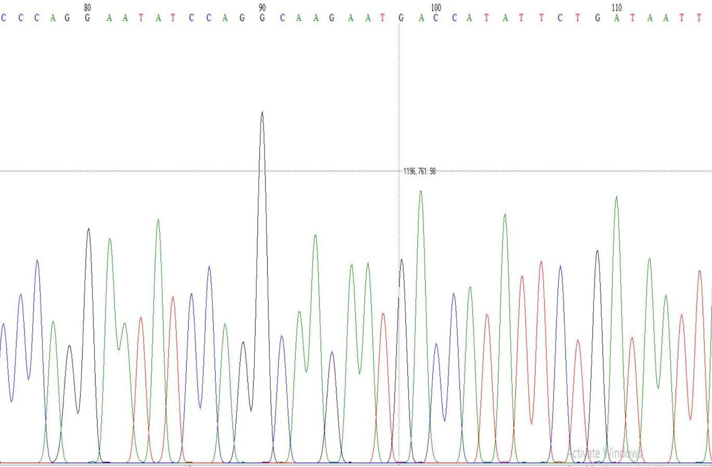
Figure 2. Representative Sanger sequencing chromatogram of the rs12255372 GG genotype, showing a single guanine (G) peak at the polymorphic locus.
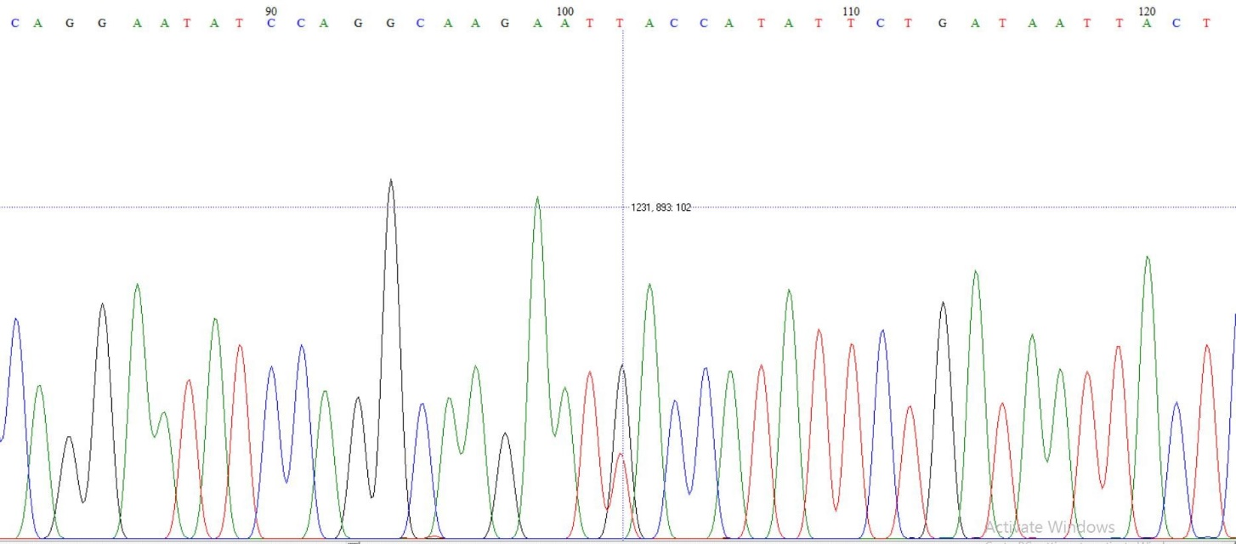

Figure 3. Representative Sanger sequencing chromatogram of the rs12255372 GT genotype, showing overlapping guanine (G) and thymine (T) peaks at the polymorphic locus.
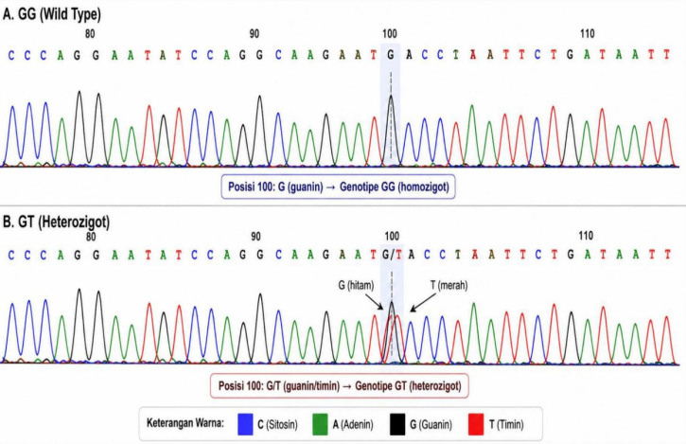
Figure 4. Summary of rs12255372 genotype patterns identified in this study: GG (wild-type homozygote) and GT (heterozygote).

Association Between rs12255372 and T2DM
Fisher’s exact analysis showed no statistically significant association between rs12255372 polymorphism and T2DM susceptibility. Compared with the GG genotype, the GT genotype was not associated with increased odds of T2DM (OR 1.08; 95% CI 0.19–6.16; p=0.93).

Table 4. Association Between rs12255372 and T2DM
Genotype/Allele | OR (95% CI) | p-value
GG  GT | Reference  1.08 (0.19–6.16) | 0.93

Association with C-Peptide Levels
Median C-peptide levels tended to be higher among GT carriers than GG carriers; however, the difference did not reach statistical significance.

Table 5. Comparison of C-Peptide Levels according to genotype
Genotype | Median C-peptide(IQR) ng/mL | p-value
GG (n=175) 2.1 (1.5–2.5)  GT (n=6) | 2.1 (1.5–2.5)  2.4 (2.1–2.6) | 0.157

Association with Insulin Resistance
Median HOMA-IR values were slightly higher among GT carriers than GG carriers, but the difference was not statistically significant.

Table 6. Comparison of HOMA-IR according to genotype
Genotype | Median HOMA-IR (IQR) | p-value
GG (n=175) 2.1 (1.5–2.5)  GT (n=6) | 2.7 (1.6–3.6)  3.0 (1.9–3.7) | 0.609

Multivariate Logistic Regression
Multivariate logistic regression analysis demonstrated that age, BMI, and sex were stronger independent predictors of T2DM susceptibility than rs12255372 genotype. In contrast, rs12255372 genotype was not independently associated with T2DM in the adjusted model.

Table 7. Multivariate Logistic Regression Analysis for T2DM
Variable | OR | 95% CI | p-value
rs12255372 genotype | 0.646 | 0.070–5.969 | 0.700
Age | 1.323 | 1.199–1.459 | <0.001
BMI | 0.752 | 0.677–0.835 | <0.001
Sex | 3.077 | 1.020–9.283 | 0.046

DISCUSSION
This study investigated the association between the TCF7L2 rs12255372 polymorphism, T2DM susceptibility, C-peptide levels, and insulin resistance in an Indonesian population. The principal finding was that rs12255372 was not significantly associated with T2DM susceptibility or metabolic phenotypes, including C-peptide concentration and HOMA-IR. Although GT carriers exhibited slightly higher median C-peptide and HOMA-IR values than GG carriers, these differences were not statistically significant. Furthermore, multivariate logistic regression demonstrated that age, body mass index (BMI), and sex were stronger independent predictors of T2DM than the rs12255372 genotype.
The absence of a significant association is consistent with several studies conducted in Asian populations, where the T allele frequency of rs12255372 is considerably lower than that reported in European populations. Previous investigations in East and Southeast Asia have similarly reported low frequencies of the risk allele and limited evidence of association with T2DM, suggesting that the contribution of this variant differs substantially across ethnic groups. Large multi-ancestry GWAS have demonstrated that the magnitude of T2DM genetic effects differs substantially across ancestral populations because of differences in allele frequencies and linkage disequilibrium patterns [16,26,27]. These findings emphasize that genetic variants identified in one ancestry cannot be directly extrapolated to other populations without local validation, underscoring the importance of population-specific genetic studies [10,11,12,13,22].
Despite the absence of a statistically significant association in the present study, the biological role of TCF7L2 in glucose metabolism and β-cell biology remains well established. Experimental, functional genomic, and translational studies have consistently demonstrated that TCF7L2 regulates Wnt/β-catenin signaling, pancreatic β-cell proliferation, incretin biology, and insulin secretion [5,16,17,18,19,23]. Clinical studies have further demonstrated that TCF7L2 variants influence clinical presentation, glycemic control, and the risk of diabetes-related complications, although the magnitude of these effects varies across populations [24]. Recent advances further support β-cell dysfunction as the central mechanism underlying T2DM progression and highlight the importance of integrating genetic findings with biomarkers of endogenous insulin secretion, including C-peptide [25]. Moreover, recent functional genomic evidence suggests that multiple regulatory variants within the TCF7L2 locus may exert tissue-specific effects, indicating that rs12255372 may function primarily as a marker in linkage disequilibrium with nearby causal variants rather than representing the causal variant itself [20,26].
Another important observation was the complete absence of the TT genotype, with only a small proportion of participants carrying the heterozygous GT genotype. This restricted genotype distribution substantially reduced statistical power to detect modest genetic effects and likely reflects the rarity of the T allele in the Indonesian population. Similar genotype distributions have been reported in other Asian cohorts, further supporting the existence of marked ethnic heterogeneity in the genetic architecture of T2DM. Consequently, larger multicenter studies and genome-wide approaches are required to identify genetic variants that better explain T2DM susceptibility in Indonesian populations. The observed low frequency of the T allele is also compatible with current evidence showing substantial genetic heterogeneity across global populations and supports the importance of ancestry-specific genetic architecture in T2DM [21,27,28].
This study has several strengths, including the use of PCR followed by Sanger sequencing for genotype validation, comprehensive metabolic phenotyping, and multivariate statistical analysis. Nevertheless, several limitations should be acknowledged. The study was conducted at a single center with a relatively modest sample size, and the low frequency of the T allele limited the ability to detect small genetic effects. In addition, only one TCF7L2 polymorphism was investigated. Future studies involving larger multiethnic cohorts and comprehensive genomic analyses are warranted to clarify the genetic determinants of T2DM in Indonesia and to support the development of precision medicine strategies. Future studies integrating polygenic risk scores, whole-genome sequencing, and functional genomics may improve genetic risk prediction in Southeast Asian populations [19,21,23].

CONCLUSION
In conclusion, the TCF7L2 rs12255372 polymorphism was not significantly associated with T2DM susceptibility, C-peptide levels, or insulin resistance in this Indonesian population. The very low frequency of the T allele and the absence of TT homozygotes underscore substantial ethnic variation in the genetic architecture of T2DM and suggest that the contribution of rs12255372 to T2DM susceptibility in Indonesians is likely modest. In contrast, age, BMI, and sex emerged as stronger predictors of T2DM than genotype in the present cohort.
These findings underscore the importance of population-specific genetic evaluation in diabetes research and caution against direct extrapolation of risk variants identified in other ancestral groups to Indonesian populations without local validation. Future multicenter studies incorporating genome-wide analyses, functional genomics, and precision medicine approaches are warranted to better characterize T2DM susceptibility in Indonesian populations [19,20,21,26,28].

STUDY LIMITATIONS
Several limitations of this study should be acknowledged. First, the low frequency of the rs12255372 T allele and the absence of TT homozygotes reduced statistical power to detect modest associations. Second, the small number of GT carriers limited genotype-stratified metabolic analyses. Third, only one SNP in the TCF7L2 gene was evaluated, precluding assessment of haplotypes and interactions with other diabetogenic loci. Finally, the single-center nature of the study may limit generalizability to the broader Indonesian population.

- ACKNOWLEDGEMENT
The authors sincerely thank all participants involved in this study. We also thank the staff of Hasanuddin University Hospital, Samarinda Regional Health Laboratory, and the Biomolecular Teaching Hospital Laboratory of HUM-RC, Hasanuddin University, Makassar, for their assistance during participant recruitment, laboratory analysis, and molecular examination. The authors gratefully acknowledge the support provided through the Golden Generation GratisPol Scholarship Program of the East Kalimantan Provincial Government.

- DECLARATIONS

Author Contributions
Conceptualization, methodology, investigation, data curation, formal analysis, and writing—original draft preparation: Prince Saputra. Conceptualization, methodology, supervision, and critical revision of the manuscript: Liong Boy Kurniawan and Mansyur Arif. Laboratory investigation, PCR amplification, and Sanger sequencing validation: Rusdina Bte Latju. Statistical analysis, data interpretation, and manuscript review: Andi Alfian. Clinical input on participant eligibility criteria, interpretation of clinical aspects of the study, and manuscript review: Himawan Sanusi. Bioinformatics-related input, interpretation of molecular findings, and critical revision of the manuscript: Miswar Fattah. All authors have read and approved the final version of the manuscript.

Funding

This study was supported by the Pendidikan GratisPol Generasi Emas Scholarship Program of the Government of East Kalimantan Province, Indonesia.

Institutional Review Board Statement

This study was conducted in accordance with the Declaration of Helsinki and was approved by the Health Research Ethics Committee of Hasanuddin University, Indonesia (Approval No. 563/UN4.6.4.5.31/PP36/2025).

Informed Consent Statement

Written informed consent was obtained from all participants prior to enrollment. Participant confidentiality was strictly maintained throughout the study.

Data Availability Statement

The data supporting the findings of this study are available from the corresponding author upon reasonable request.

Disclosure Statement

The authors declare that they have no competing interests.

Abbreviations

T2DM, type 2 diabetes mellitus;
T1DM, type 1 diabetes mellitus;
TCF7L2, transcription factor 7-like 2;
SNP, single nucleotide polymorphism;
BMI, body mass index;
HbA1c, glycated hemoglobin;
C-peptide, connecting peptide;
HOMA-IR, homeostasis model assessment of insulin resistance;
PCR, polymerase chain reaction;
HWE, Hardy–Weinberg equilibrium.

REFERENCES
- Dilworth L, Facey A, Omoruyi F. Diabetes mellitus and its metabolic complications: the role of adipose tissues. Int J Mol Sci. 2021;22:7644. doi:10.3390/ijms22147644.
- Galicia-Garcia U, Benito-Vicente A, Jebari S, Larrea-Sebal A, Siddiqi H, Uribe KB, et al. Pathophysiology of type 2 diabetes mellitus. Int J Mol Sci. 2020;21(17):6275. doi:10.3390/ijms21176275.
- Genitsaridi I, Salpea P, Salim A, Sajjadi SF, Tomic D, James S, et al. 11th edition of the IDF Diabetes Atlas: global, regional, and national diabetes prevalence estimates for 2024 and projections for 2050. Lancet Diabetes Endocrinol. 2025. doi:10.1016/S2213-8587(24)00358-4.
- Singh S, Kriti M, Sarma DK, Verma V, Nagpal R, Mohania D, et al. Deciphering the complex interplay of risk factors in type 2 diabetes mellitus: a comprehensive review. Metab Open. 2024;22:100287. doi:10.1016/j.metop.2024.100287.
- Del Bosque-Plata L, Martínez-Martínez E, Espinoza-Camacho MÁ, Gragnoli C. The role of TCF7L2 in type 2 diabetes. Diabetes. 2021;70(6):1220-1228. doi:10.2337/db20-0573.
- Huang ZQ, Liao YQ, Huang RZ, Chen JP, Sun HL. Possible role of TCF7L2 in the pathogenesis of type 2 diabetes mellitus. Biotechnol Biotechnol Equip. 2018;32(4):830-834. doi:10.1080/13102818.2018.1438211.
- Witka BZ, Oktaviani DJ, Marcellino M, Barliana MI, Abdulah R. Type 2 diabetes-associated genetic polymorphisms as potential disease predictors. Diabetes Metab Syndr Obes. 2019;12:2689-2706. doi:10.2147/DMSO.S230061.
- Zeini M, Laurenti MC, Egan AM, Muthusamy K, Ramar A, Vella E, et al. The longitudinal effect of diabetes-associated variation in TCF7L2 on islet function in humans. Diabetes. 2024;73(9):1440-1446. doi:10.2337/db24-0192.
- Elhourch S, Arrouchi H, Mekkaoui N, Allou Y, Ghrifi F, Allam L, et al. Significant association of polymorphisms in the TCF7L2 gene with a higher risk of type 2 diabetes in a Moroccan population. J Pers Med. 2021;11(6):461. doi:10.3390/jpm11060461.
- Kaur N, Kaur G, Kaur S. TCF7L2 gene rs12255372 (G/T) variant and susceptibility to type 2 diabetes mellitus in North Indians. Gene Rep. 2020;19:100595. doi:10.1016/j.genrep.2020.100595.
- Mahmood SA, Uddin MF, Mustari M, Mahjabeen S, Azad MK, Rahim CFM. TCF7L2 rs12255372 gene polymorphism and obesity in a Bangladeshi population. Indian J Endocrinol Metab. 2025;29(3):313-318. doi:10.4103/ijem.ijem_471_24.
- Ghosheh N, Naffa RG, Mashal S, Al-Khalayfa S, Battah AH, Azab B. The association of TCF7L2 gene polymorphisms, rs12255372 and rs7903146, with type 2 diabetes mellitus in the Jordanian population. Mol Biol Rep. 2025;52:461. doi:10.1007/s11033-025-10544-w.
- Lu YC, Yu TH, Hsuan CF, et al. Association of TCF7L2 rs7903146 (C/T) polymorphism with type 2 diabetes mellitus in a Chinese population: clinical characteristics and ethnic context. Diagnostics (Basel). 2025;15(16):2110. doi:10.3390/diagnostics15162110.
- Sen P, Alam SS, Jahan I, Saha P, Shill LC. Association of the TCF7L2 rs7903146 variant with type 2 diabetes mellitus and related biomarkers: a systematic review. BMJ Nutr Prev Health. 2025;8(2):e001205. doi:10.1136/bmjnph-2025-001205.
- Blanken CPS, Bayer S, Buchner Carro S, Hauner H, Holzapfel C. Associations between TCF7L2, PPARG, and KCNJ11 genotypes and insulin response to an oral glucose tolerance test: a systematic review. Mol Nutr Food Res. 2025;69(3):e202400561. doi:10.1002/mnfr.202400561.
- Evans-Molina C. Advances in basic biology and translation in islet research. Nat Rev Endocrinol. 2025;21:69–70. doi:10.1038/s41574-024-01073-w.
- Adeerjiang Y, Sidike A, Gan XX, Li QT, Jiang S. The role of Wnt3a/β-catenin/TCF7L2 pathway in diabetes and cardiorenal complications. Cardiorenal Med. 2025;15(1):72–82. doi:10.1159/000543145.
- Ansari S, Khoo B, Tan T. Targeting the incretin system in obesity and type 2 diabetes mellitus. Nature Reviews Endocrinology. 2024;20:447–459. doi:10.1038/s41574-024-00979-9.
- Prasad RB, Groop L. Precision diagnostics in diabetes: from genetic discovery to clinical implementation. J Clin Invest. 2025;135:e182431. doi:10.1172/JCI182431.
- Claussnitzer M, Mahajan A, McCarthy MI.Functional genomics of type 2 diabetes risk variants.Nat Rev Genet. 2025;26:165–182.doi:10.1038/s41576-024-00759-2.
- Ortega HI, Udler MS, Gloyn AL, et al. Diabetes mellitus polygenic risk scores: heterogeneity and clinical translation. Nat Rev Endocrinol. 2025;21:530–545.doi:10.1038/s41574-025-01074-3.
- Plengvidhya N, Teerawattanapong N, Narkdontr T, et al. Cluster-specific genetic associations of CDKAL1, CDKN2A, CDKN2B, HHEX, KCNQ1, MTNR1B, PAX4, SLC30A8, TCF7L2, and UBE2E2 variants in new onset type 2 diabetes. Sci Rep. 2025;16:2983. doi:10.1038/s41598-025-32840-y.
- Maynard AG, Bhardwaj R, Jones TR, Claussnitzer M. Bridging the variant-to-function gap in type 2 diabetes: advances and challenges. Diabetologia. 2025. doi:10.1007/s00125-025-06600-6.
- Hansen AL, Andersen MK, Engelhard LM, Brøns C, Hansen T, Nielsen JS, et al. Impact of TCF7L2 rs7903146 on clinical presentation and risk of complications in patients with type 2 diabetes. Diabetes Obes Metab. 2025;27(4):2002-2011. doi:10.1111/dom.16193.
- Yau B, Ghislain J, Kebede MA, et al. The role of the beta cell in type 2 diabetes: new findings from the last 5 years. Diabetologia. 2025;68:2092–2103. doi:10.1007/s00125-025-06499-z.
- Mahajan A, Wessel J, Willems SM, et al.Fine-mapping type 2 diabetes loci to single-variant resolution using high-density imputation and islet-specific epigenome maps.Nat Genet. 2024;56:1458–1470.doi:10.1038/s41588-024-01922-7.
- Suzuki K, Hatzikotoulas K, Southam L, et al. Genetic drivers of heterogeneity in type 2 diabetes pathophysiology. Nature. 2024;627:347-357. doi:10.1038/s41586-024-07019-6.
- Vujkovic M, Keaton JM, Lynch JA, et al.Discovery of novel loci associated with type 2 diabetes through multi-ancestry genome-wide association analyses.Nat Genet. 2024;56:1123–1135.doi:10.1038/s41588-024-01834-6.

